**Northeastern University**

360 Huntington Ave, Boston, MA 02115



**Report on**

**IMU and GPS Data Analysis**

**LAB_4** - EECE 5554 Robotics Sensing and Navigation

**Submitted by:**

**Pavan Rathnakar Shetty**

**Submitted to**

**Hanumant Singh**

**Professor, Electrical and Computer Engineering**

**Detailed Analysis: For the 1st and 2nd questions, data analysis is described in new.m, for the 3rd question, Data Analysis is described in fusion1.m last part.**

1. **Magnetometer Calibration:**

***Submit plots showing the magnetometer data before and after the correction in your report.***

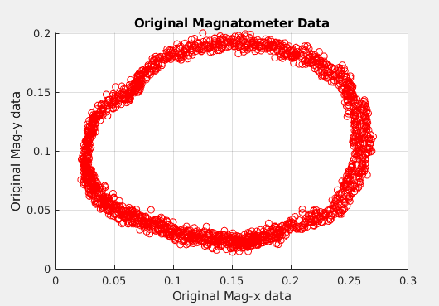

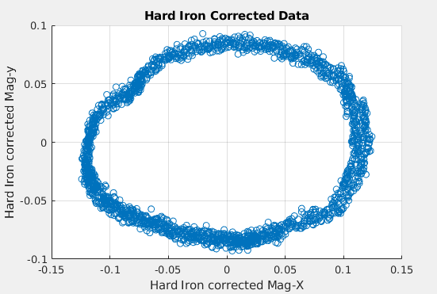

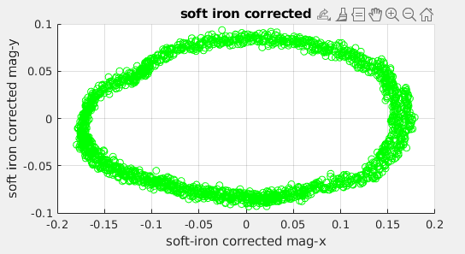

**Calculate the yaw angle from the corrected magnetometer readings.**

This is done by offsetting the center which accounts for hard iron correction and rotating the ellipse

which accounts for soft iron correction.

**Integrate the yaw rate sensor to get the yaw angle.**

***Compare the yaw angle from the above two methods.***

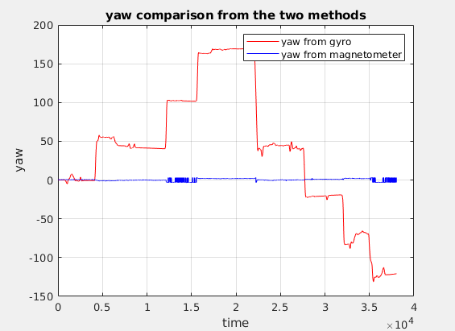

**Comparison:** They have similar peaks, but due to bias, on integration, the values add up and scales when

Compared to the yaw calculated by magnetometer value. So the best method of bias reduction is scaling down

by a value as described in new.m code.

Also using a complimentary filter to the yaw angle calculated from the above two methods will result in a

Similar plot to that of raw yaw imu readings.

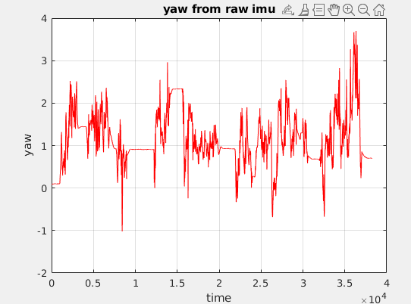

**Use a complementary filter to combine the measurements from the magnetometer and yaw rate**

***Compare your result to the yaw angle computed by the IMU and write down your observations.***

They have similar peaks, but due to bias, on integration, the values add up and scales when compared to raw

Yaw imu data.

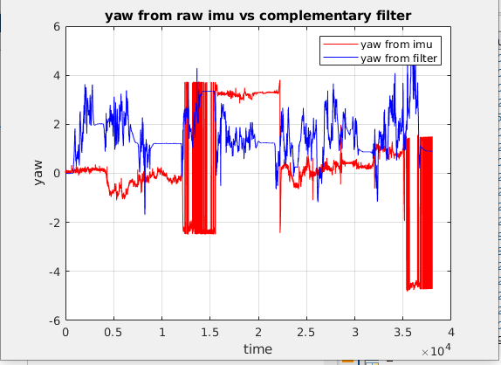

**2)**

**Calculate an estimate of the velocity from your GPS measurements.**

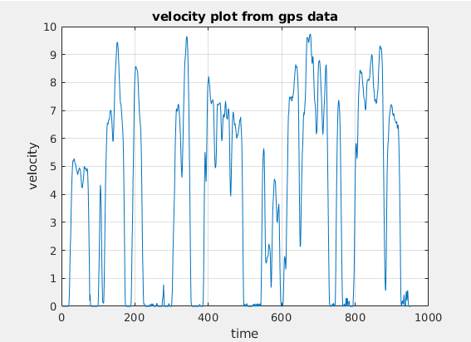

**Integrate the forward acceleration to estimate the forward velocity.**

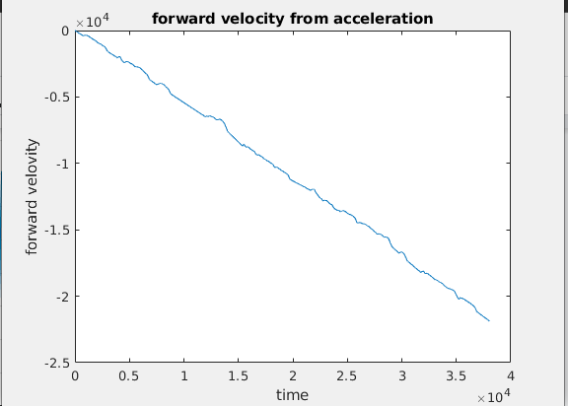

**Make observations on the plot. Does the integrated velocity estimate make sense?**

**Ans:**

Since the frequency of the imu data and GPS data is different, we have more points in imu values. And on

Integration, the noise, and bias adds up making the integrated plot unreliable. This has to be corrected before

Integrating by averaging out the sample and stationary corrections. Also scaling with a negative factor helps

Changing the negative trend of the integrated velocity.

**Make adjustments to the acceleration measurements to make the velocity plot more reasonable.**

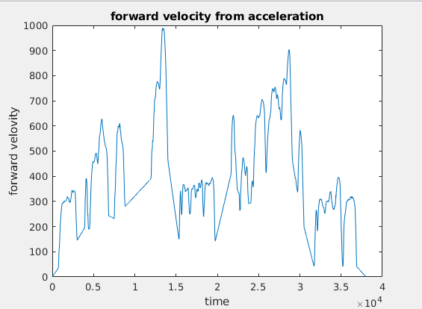

***Provide the rationale you use for the adjustments and plot the adjusted velocity.***

**Ans:**

Due to deceleration, the acceleration dips in the negative direction, and on integration, this bias will add up.

So, to rectify it, the gaussian noise can be averaged out to get a better sample.

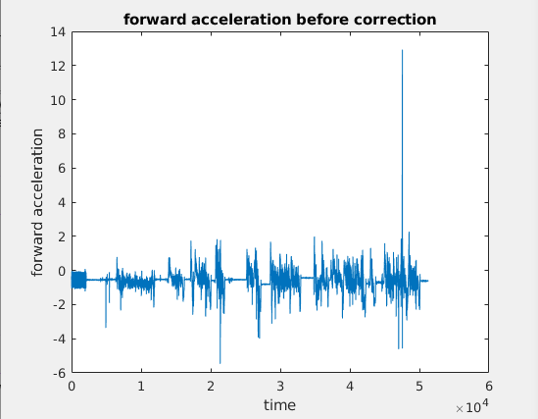

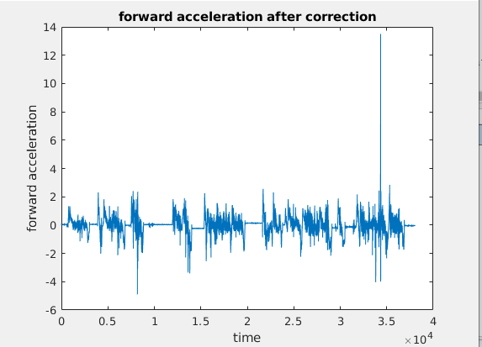

**3)**

**2)Dead Reckoning with IMU(logic explained in code)**

**Integrate IMU data to obtain displacement and compare with GPS.**

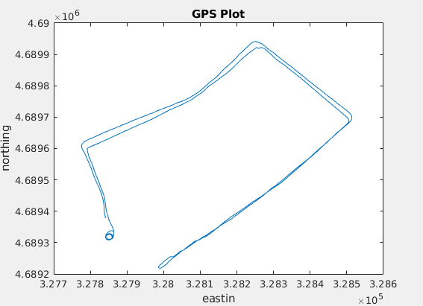

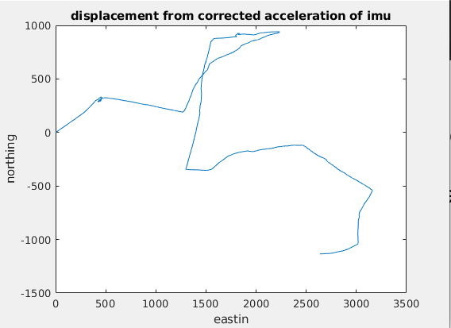

**Ans:** Unfortunately I was unable to resize, fix the offset and scale my displacement found from integrating

Velocity which was found by multiplying calculated yaw from mag as horizontal and bertical components

With acceleration.

**Compute omega*Xdot and compare it to imu acceleration. How well do they agree? If there is a difference, what is it due to?**

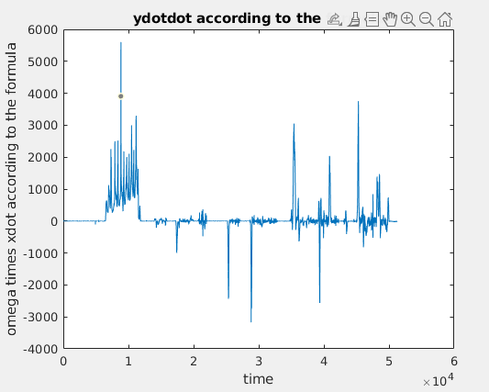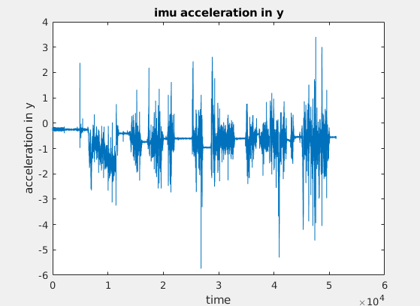

**Ans:**

On integration, the bias adds up and we find it sloping away compared to the acceleration plot from the imu.

Also, the bias being added up in the opposite to imu acceleration about y graph.

3)Estimate Xc:

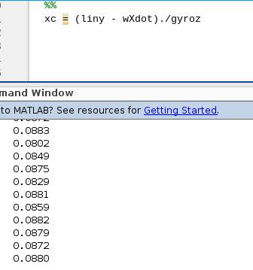

The average value of xc is found to be 0.0872m which is 8.72cm.